**How to create a non-employee TMS Account**

**for Conference Attendance**

1. Go to <https://www.tms.va.gov/SecureAuth35>
2. Select “Create New Non-Employee User”

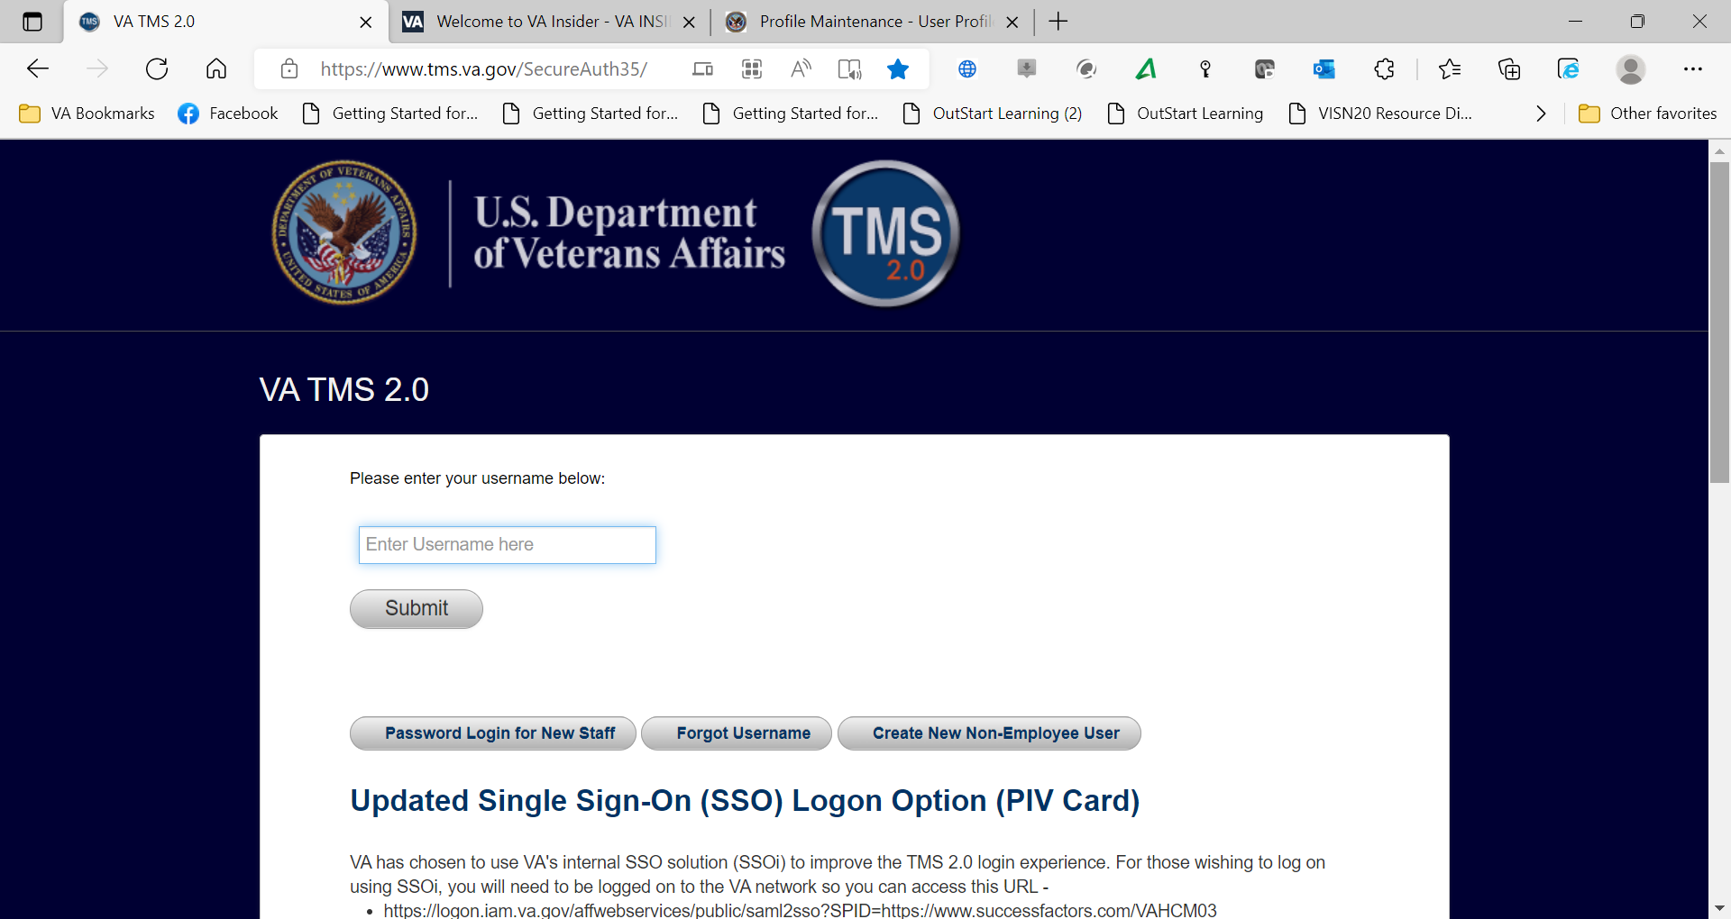

1. Select “Veterans Health Administration” then the “Next” button at the bottom of the page.

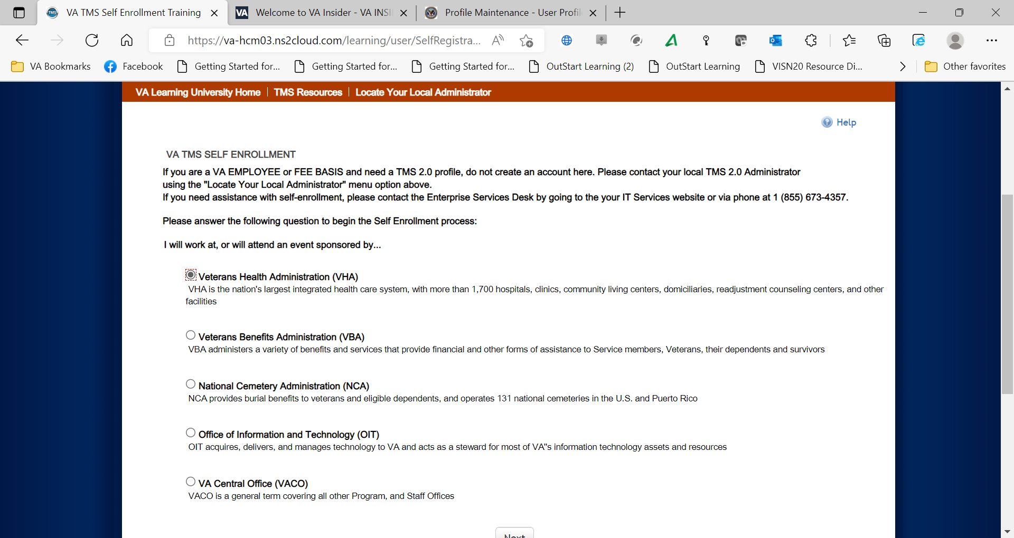

1. Select “Conference Attendee” (last option) then the “Next” button at the bottom of the page

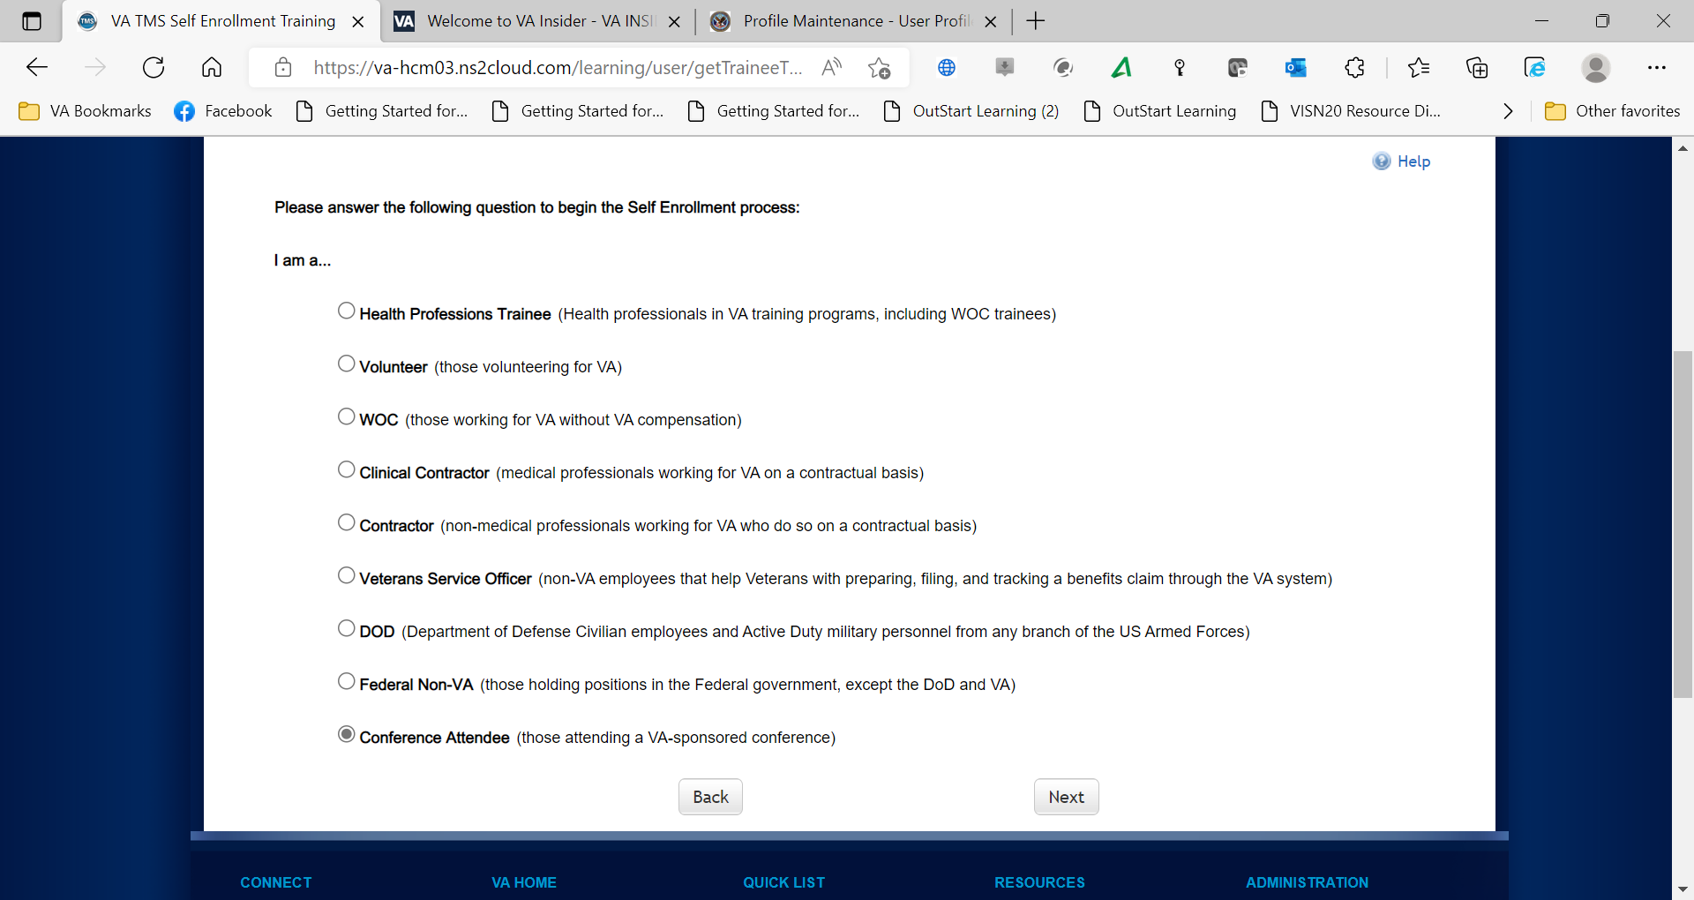

1. Enter all fields with Red Asterisk*, then hit Submit
2. Enter all required personal information
3. “Conference Information” is the following:

VA Location: *BOI*

VA Point of Contact First Name: *Cody*

VA Point of Contact Last Name: *McGee*

VA Point of Contact Email Address: [*cody.mcgee@va.gov*](mailto:cody.mcgee@va.gov)

Point of Contact Phone #: 208-422-1000

Accreditation Occupation Category: Select as desired

Preferred Accreditation: Select as desired

Conference ID: *20238899*

Conference Name: *BOI VAMC Grand Rounds*

Conference Start Date: Enter date you plan to initially attend

Conference Location: *BOI VAMC*

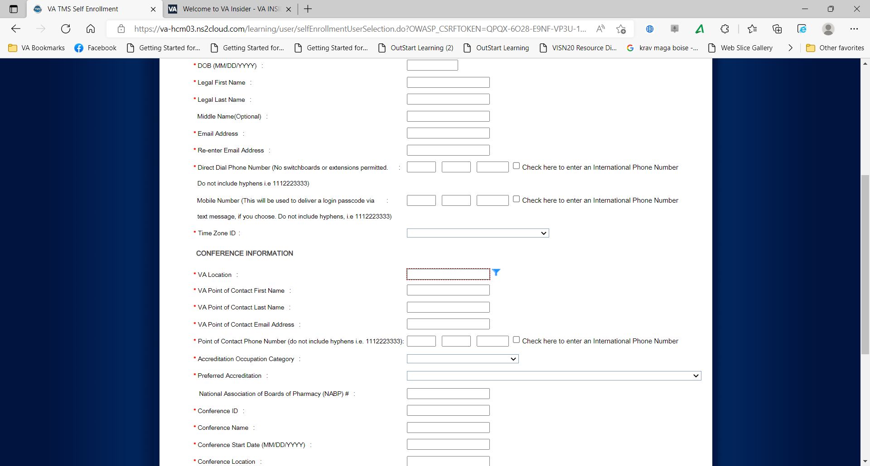

*Note: If there were any errors identified after selecting* ***SUBMIT****, you must fix those and then select* ***SUBMIT*** *again. Keep making corrections until you succeed.*

Once any errors have been corrected, you should see the **Congratulations** screen. At this point you should make note of your TMS Username (which will be the Email Address that you entered). Once you click “Continue”, the following User ID message will display. Click ***TMS 2.0 Login*** to proceed.

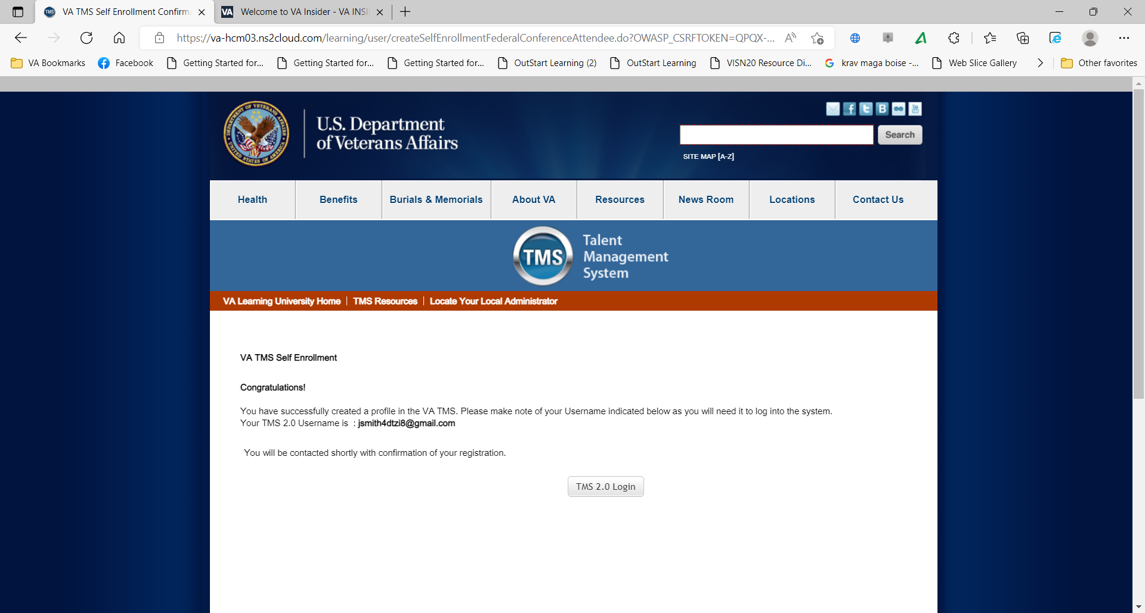

1. After 20 minutes have passed, please return to [https://www.tms.va.gov/SecureAuth35/](https://www.tms.va.gov/SecureAuth35/%20) and enter your Username and click Submit. TMS requires a double authentication to access. After you enter your User name and submit you will need to get a passcode to access. The passcode will be mailed to the email address you provided above.

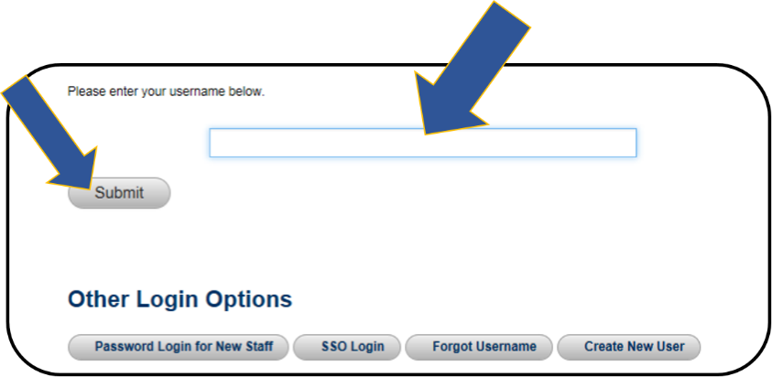

Once your Passcode arrives, enter it using your keyboard, or the on-screen number pad, and click Submit.

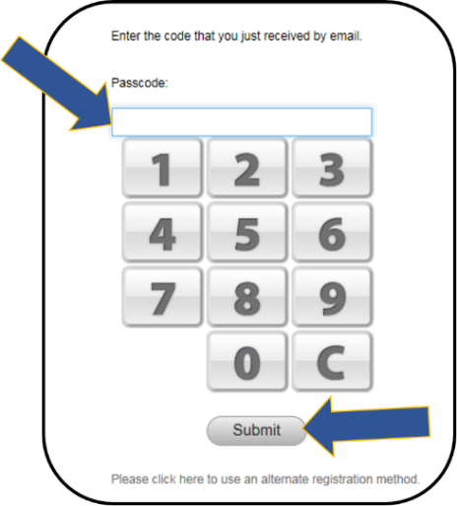

You will be asked to select and provide answers to two security questions. These will be used if you need to reset your TMS password.

Snapshot of the Set Security Questions screen where you must select two questions and enter and re-enter the answers to these questions. After the questions and answer responses, there is a SAVE button

After selecting your questions and entering your answers, select the **SAVE** button.

At this point, you have now created your TMS User Profile

**KEEP TRACK OF YOUR TMS LOGIN AND PASSWORD. YOU WILL NEED IT THROUGHOUT THIS PROCESS**

1. **After the end of the program – verify and evaluate the education within 15 days to obtain your accredited certificate.**

After the program, log in to the TMS homepage (<https://www.tms.va.gov/SecureAuth35/>). Sign in using your user ID. If you want to print your certificate, be sure your computer is connected to a printer.

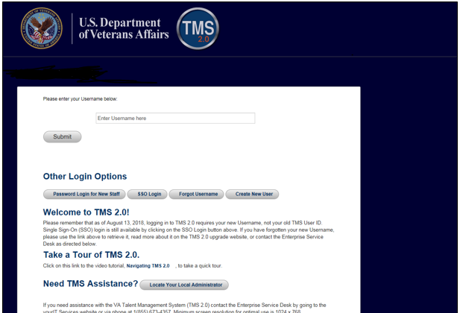

The education course you attended should be on the To-Do List. Click on the name.

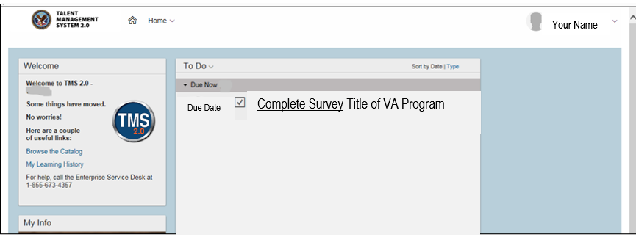

Click on “Complete Survey”, complete and submit it.

After the Survey (evaluation) has been received, you will be taken to a new page. On this page click on the “My History” tile.

Click on “View All”.

Hover the cursor over the program title click on “View Details” in the popup window that appears. DO NOT click on the “Print Certificate” here.

In the Completed Work Details screen, you should see a section named “Accreditation Details.”

Click the “Print Accredited Certificate” button next to your requested Accreditation (ACCME, ANCC, etc.)

Your Accredited certificate should appear on the screen for you to save or print.